**SOC Analyst Internship**

**Task Report**

Manasseh Mutugi

Task No: [16]



Copyright © 2025 EncryptEdge Labs. All rights reserved

Credit: Offensive Security

**Table of Contents**

**1.0 EncryptEdge Labs Internship Task Report 4**

*1.1 Introduction* 4

*1.2 Objective* 4

*1.3 Requirements* 4

**2.0 High-Level Summary 5**

*2.1 Recommendations* 5

*2.2 Risk exposure over time* 5

**3.0 Report - Methodologies 6**

*3.1 Section A: SIEM Tool Selection*

*3.2* *Section B: SIEM Tool Setup*

*3.3 Section C: Data Ingestion and Normalization*

*3.4* Section D: Basic Data Analysis

*3.5 Section E: Alerting and Reporting*

*3.6 Section F: Hands-on Labs*

***4.0 Reflection Section***

**5.0 Additionals Item(Appendix) X**

* 1. **Introduction**

In this task, one will gain practical experience using Security Information and Event Management (SIEM) tools, which are essential for security data analysis in a Security Operations Center (SOC). SIEM tools help centralize, normalize, and analyze security event data, providing insights into potential security threats and enabling efficient incident response.

* 1. **Objectives**
* Familiarize yourself with the core functionalities of SIEM tools and their role in data analysis and threat detection.
* Learn to ingest and normalize data from different sources within a network.
* Set up alerts and reports to monitor security events effectively**.** 
  1. **Requirements**
* Choose a SIEM tool such as Splunk, ELK Stack, or LogRhythm.
* Virtualization environment for installing and configuring the SIEM tool.

**2.0 High Level Summary**

**2.1 Recommendation**

To enhance the effectiveness of SIEM deployment and usage within a Security Operations Center (SOC), the following recommendations are made:

**1. Improve Data Source Coverage**

* Integrate logs from all critical assets, including firewalls, endpoints, cloud services, and identity providers (e.g., Active Directory, Azure AD).
* Ensure real-time log ingestion to enable timely detection of threats.

**2. Use Pre-Built and Custom Correlation Rules**

* Leverage vendor-provided rule sets for quick deployment.
* Develop custom correlation rules tailored to the organization's specific threat landscape and infrastructure.

**3. Enable Threat Intelligence Integration**

* Incorporate external threat intelligence feeds into the SIEM for better IOC matching.
* Automate blocking or alerting on known malicious indicators.

**4. Optimize Alerting and Prioritization**

* Tune SIEM alerts to reduce false positives and prioritize high-severity incidents.
* Implement a tiered alerting system to route issues to the correct analyst level.

**5. Train Analysts on SIEM Use**

* Conduct hands-on SIEM training for SOC analysts to improve investigation speed and confidence.
* Include search, dashboard creation, rule writing, and incident review modules in the training.

**2.2 Risk exposure over time**

This section illustrates how risk evolves based on the **implementation and maturity** of SIEM capabilities.

| **Stage** | **Risk Level** | **Explanation** |
| --- | --- | --- |
| **Pre-SIEM Deployment** | 🔺 High | Limited visibility into threats; delayed detection and response. |
| **Initial Implementation** | 🔻 Moderate | Centralized logs available, but tuning and correlation rules may be immature. |
| **Mature SIEM Use** | ✅ Low | Real-time alerts, correlation logic, and integrated response reduce exposure. |

**Insight:** The value of SIEM tools compounds over time as organizations fine-tune rules, automate responses, and broaden log coverage.

**Section A: SIEM Tool Selection**

**Research: ELK Stack as a SIEM Tool**

**What is the ELK Stack?**

The ELK Stack is a powerful open-source log management and analytics platform made up of:

1. **Elasticsearch** – Search and analytics engine for storing and querying logs.
2. **Logstash** – Ingests, processes, and transforms data from various sources.
3. **Kibana** – A visualization and dashboard tool for exploring and analyzing data.
4. **Beats (Optional, part of Elastic Stack)** – Lightweight data shippers (like Filebeat, Packetbeat, etc.).

Together, they form a highly customizable SIEM platform.

**Why Choose ELK Stack?**

**🔹 Ease of Use**

* Intuitive GUI via Kibana.
* Powerful search (Lucene/KQL syntax).
* Prebuilt dashboards and visualizations.
* Active community and documentation.

**🔹 Integration Capabilities**

* Collects data from virtually any source:
  + Firewalls
  + Endpoint logs
  + Cloud platforms (AWS, Azure, GCP)
  + Security tools (Suricata, Zeek, Osquery)
* Supports Beats & Logstash for flexible data pipelines.

🔹 **Industry Relevance**

* Widely used in SOCs and enterprises.
* Forms the core of Elastic Security, Elastic’s commercial SIEM.
* Offers compliance dashboards (e.g., PCI-DSS, HIPAA).
* Used by major organizations for threat hunting and detection.

**Use Cases**

* Centralized logging
* Real-time threat detection
* Dashboards for security metrics
* Incident investigation (search + timelines)
* Alerting and automated responses (with Watcher or Elastic Security)

**Comparison Snapshot**

| **Feature** | **ELK Stack** |
| --- | --- |
| Ease of Setup | Moderate |
| Customization | High |
| Integration | Extensive (via Beats/Logstash) |
| Community Support | Strong |
| Commercial Option | Elastic Security (paid tier) |
| Cost (Open Source) | Free, but infra required |

**Summary**

The ELK Stack is a strong SIEM choice because of:

* High integration flexibility
* Strong analytics and visualization tools
* Community and enterprise support
* A growing role in modern SOCs and threat hunting

If you're looking for a cost-effective, flexible, and powerful SIEM that can scale with your organization, ELK is a top contender.

**Section B: SIEM Tool Setup**

Install and configure the selected SIEM tool in a virtual environment.

**Step-by-Step: Run Elastic Agent**

**Download the file**

Once your connection is working, run:

*curl -L -O* [*https://artifacts.elastic.co/downloads/beats/elastic-agent/elastic-agent-9.0.0-linux-x86_64.tar.gz*](https://artifacts.elastic.co/downloads/beats/elastic-agent/elastic-agent-9.0.0-linux-x86_64.tar.gz)

**Extract and install**

*tar xzvf elastic-agent-9.0.0-linux-x86_64.tar.gz*

*cd elastic-agent-9.0.0-linux-x86_64*

*sudo ./elastic-agent install --url=https://b0126746633a4c388a9744c42ab864aa.fleet.us-east-1.aws.elastic.* 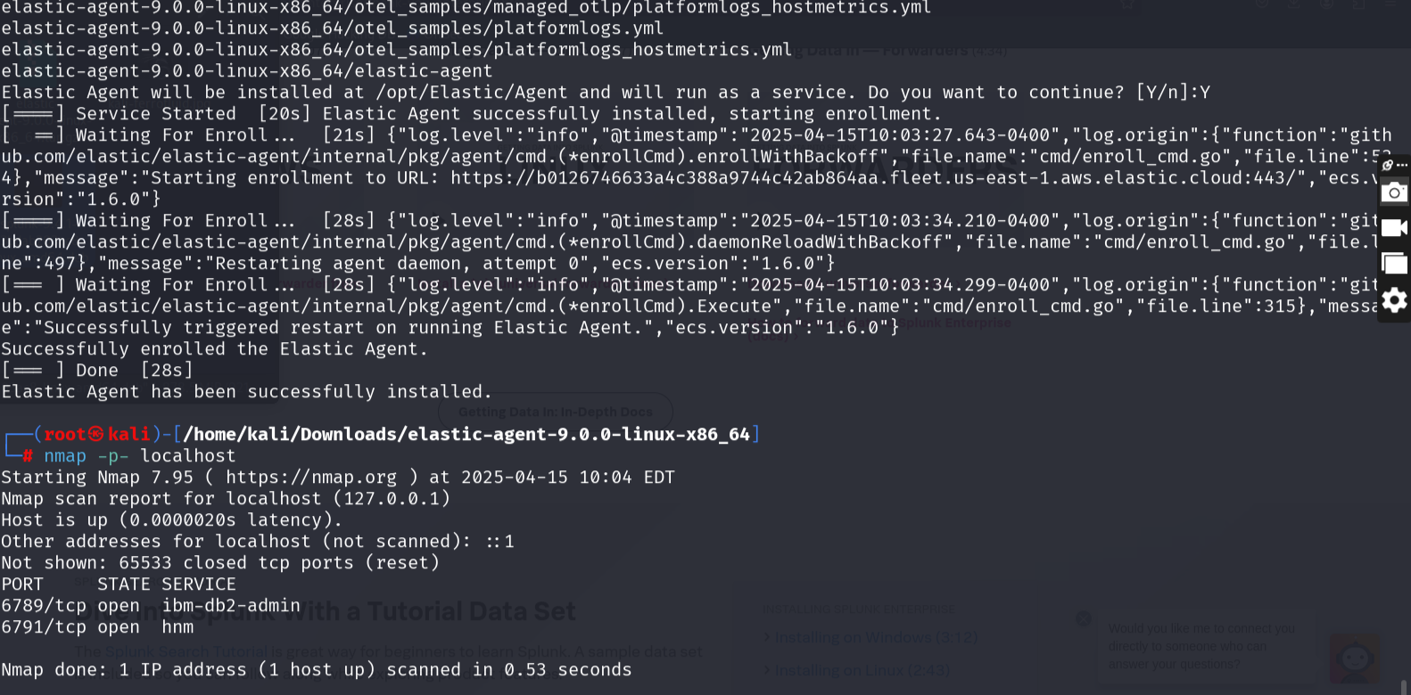

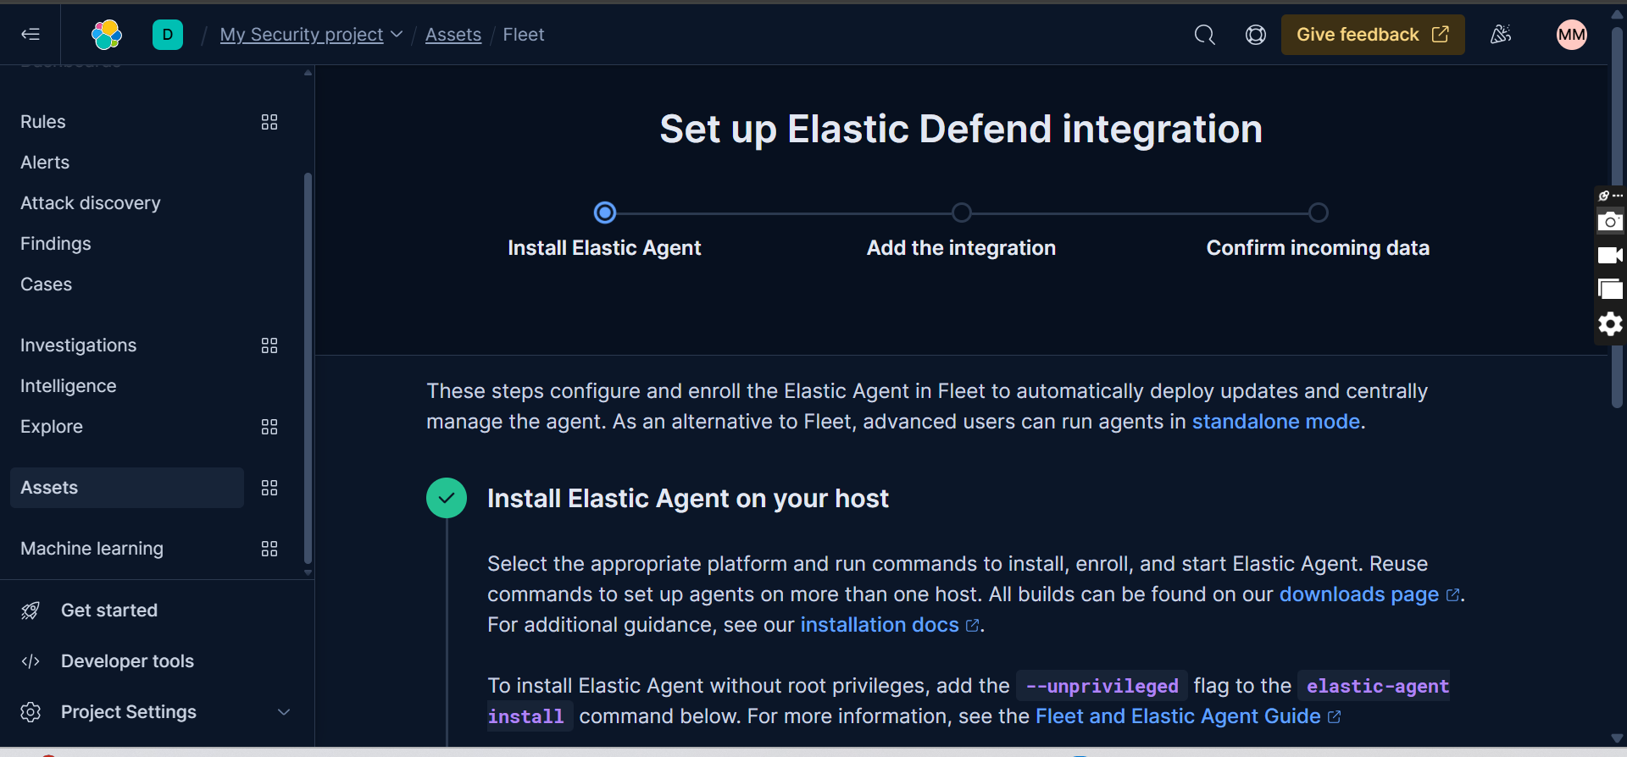

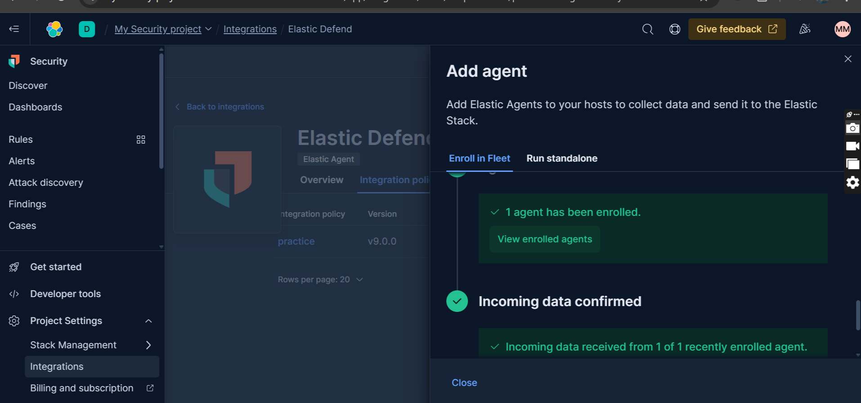

**Section C: Data Ingestion and Normalization**

Identify and integrate relevant data sources (e.g., system, firewall, and network logs).

Normalize the data to ensure consistency across different log formats.

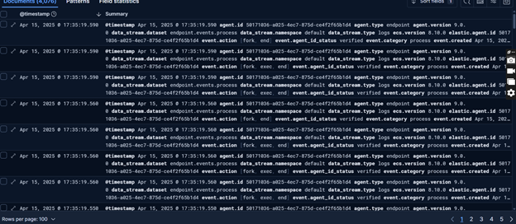

Creating a dashboard and visualization.

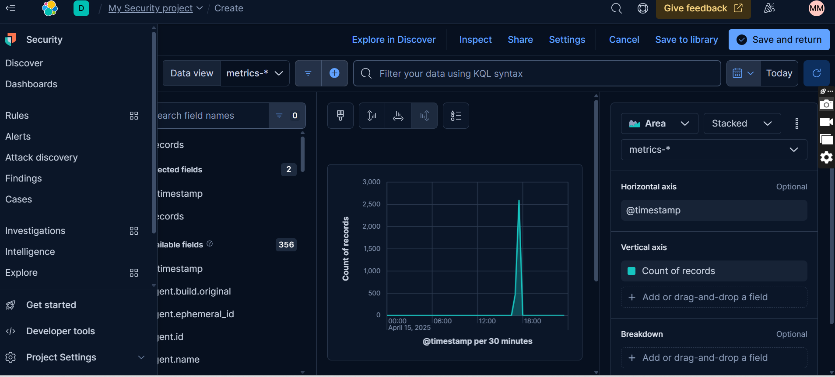

**Section E: Alerting and Reporting**

Set up alerts based on predefined security rules within the SIEM tool.

Creating a rule than can basically detect nmap scan from the host

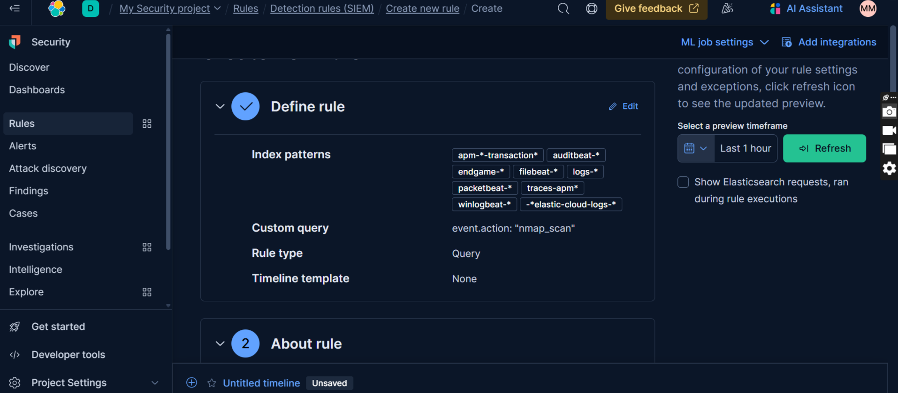

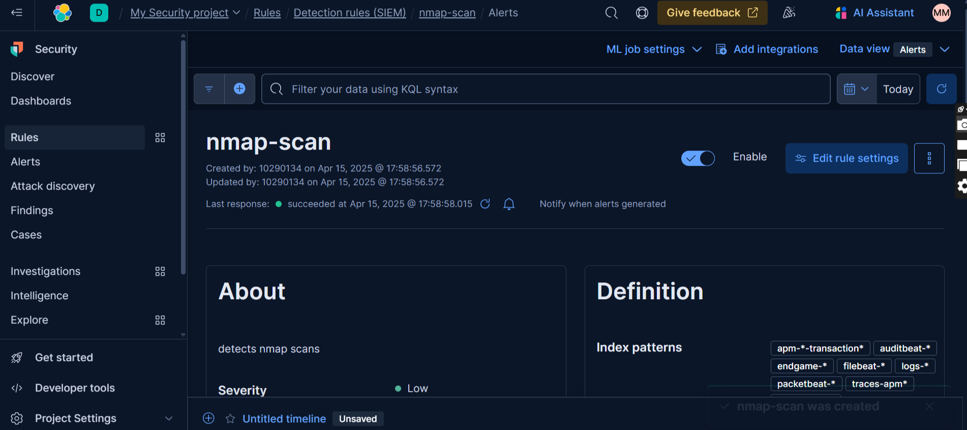

I ran some nmap scans below

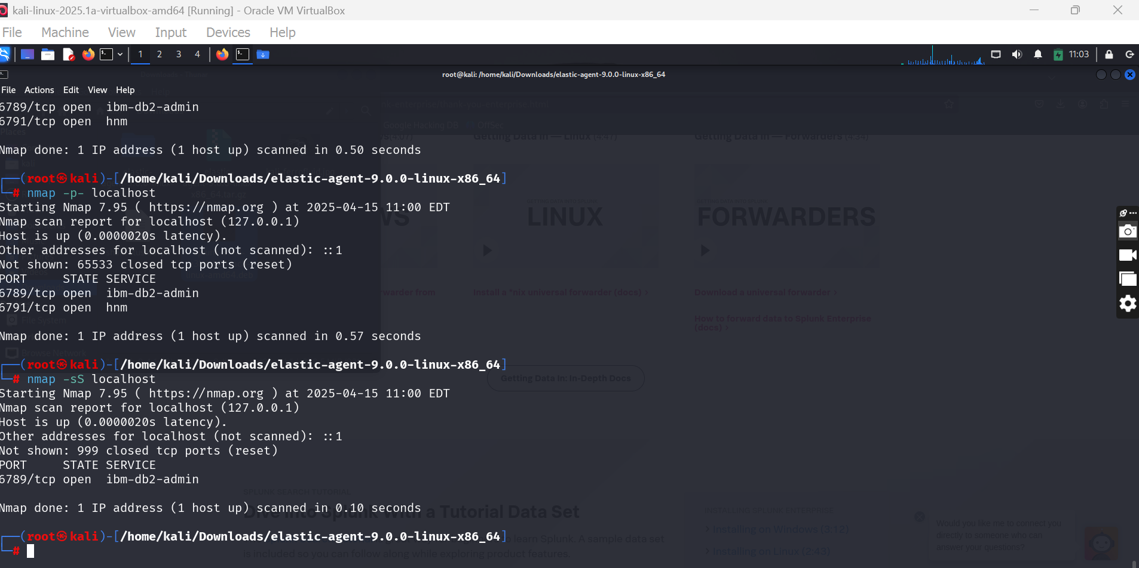

We can notice there was some spike in the activities after 1800hrs showing that they were detected

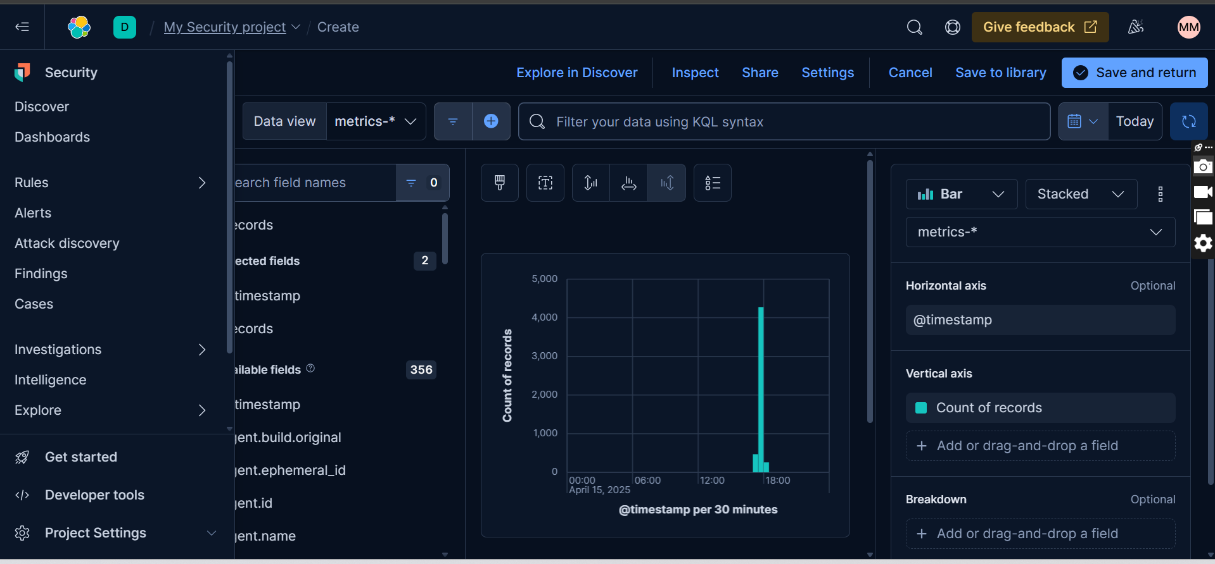

**Section F: Hands-on Labs**

**Room: Introduction To SIEM**

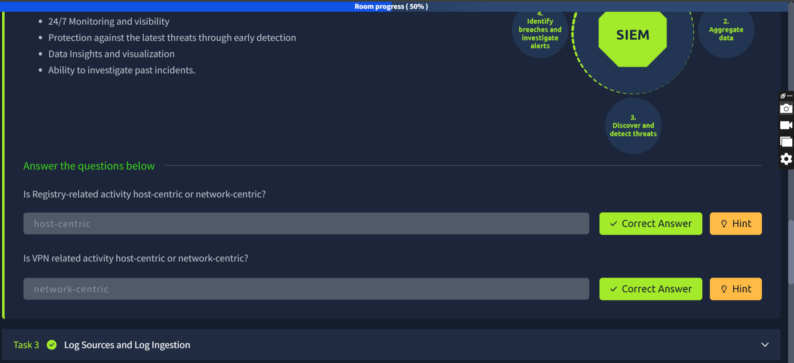

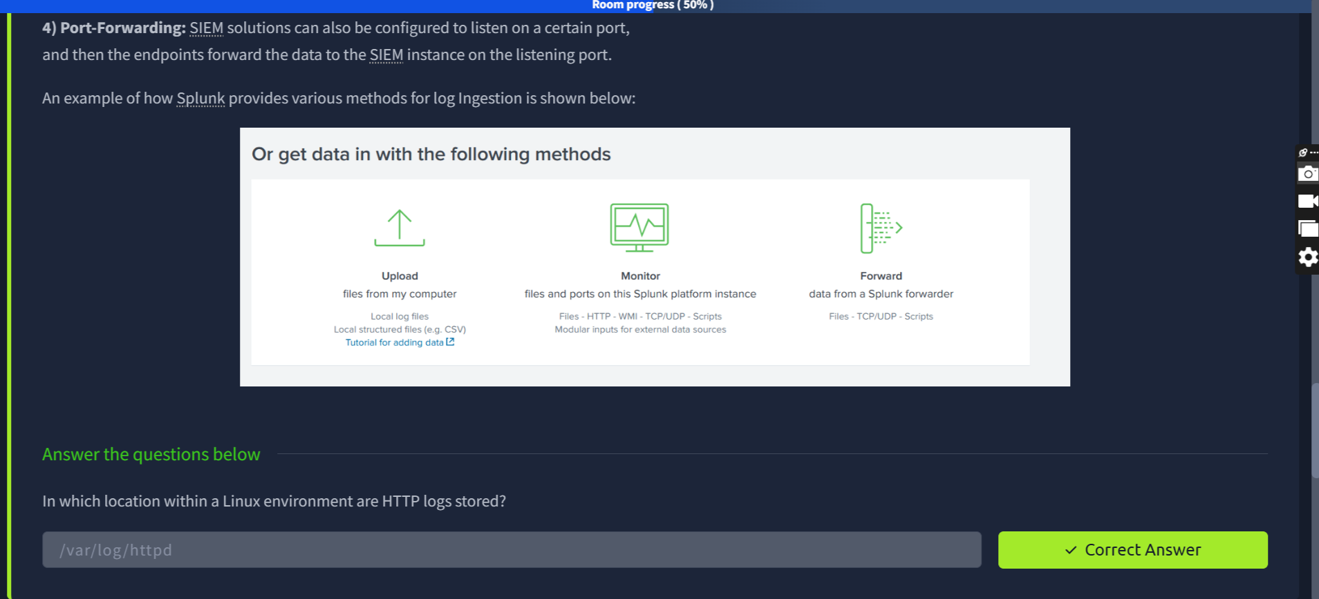

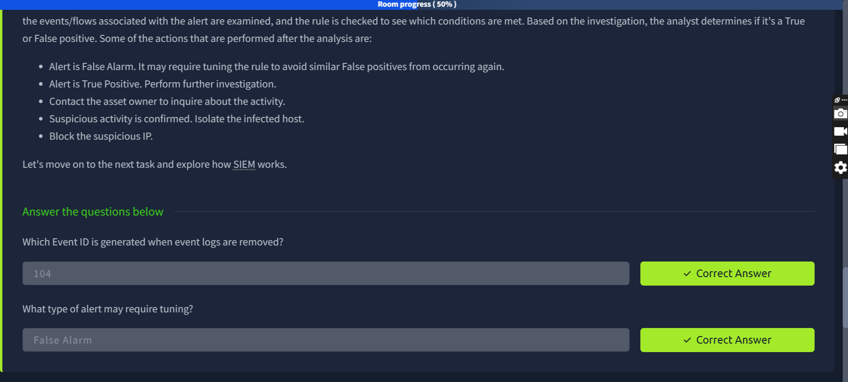

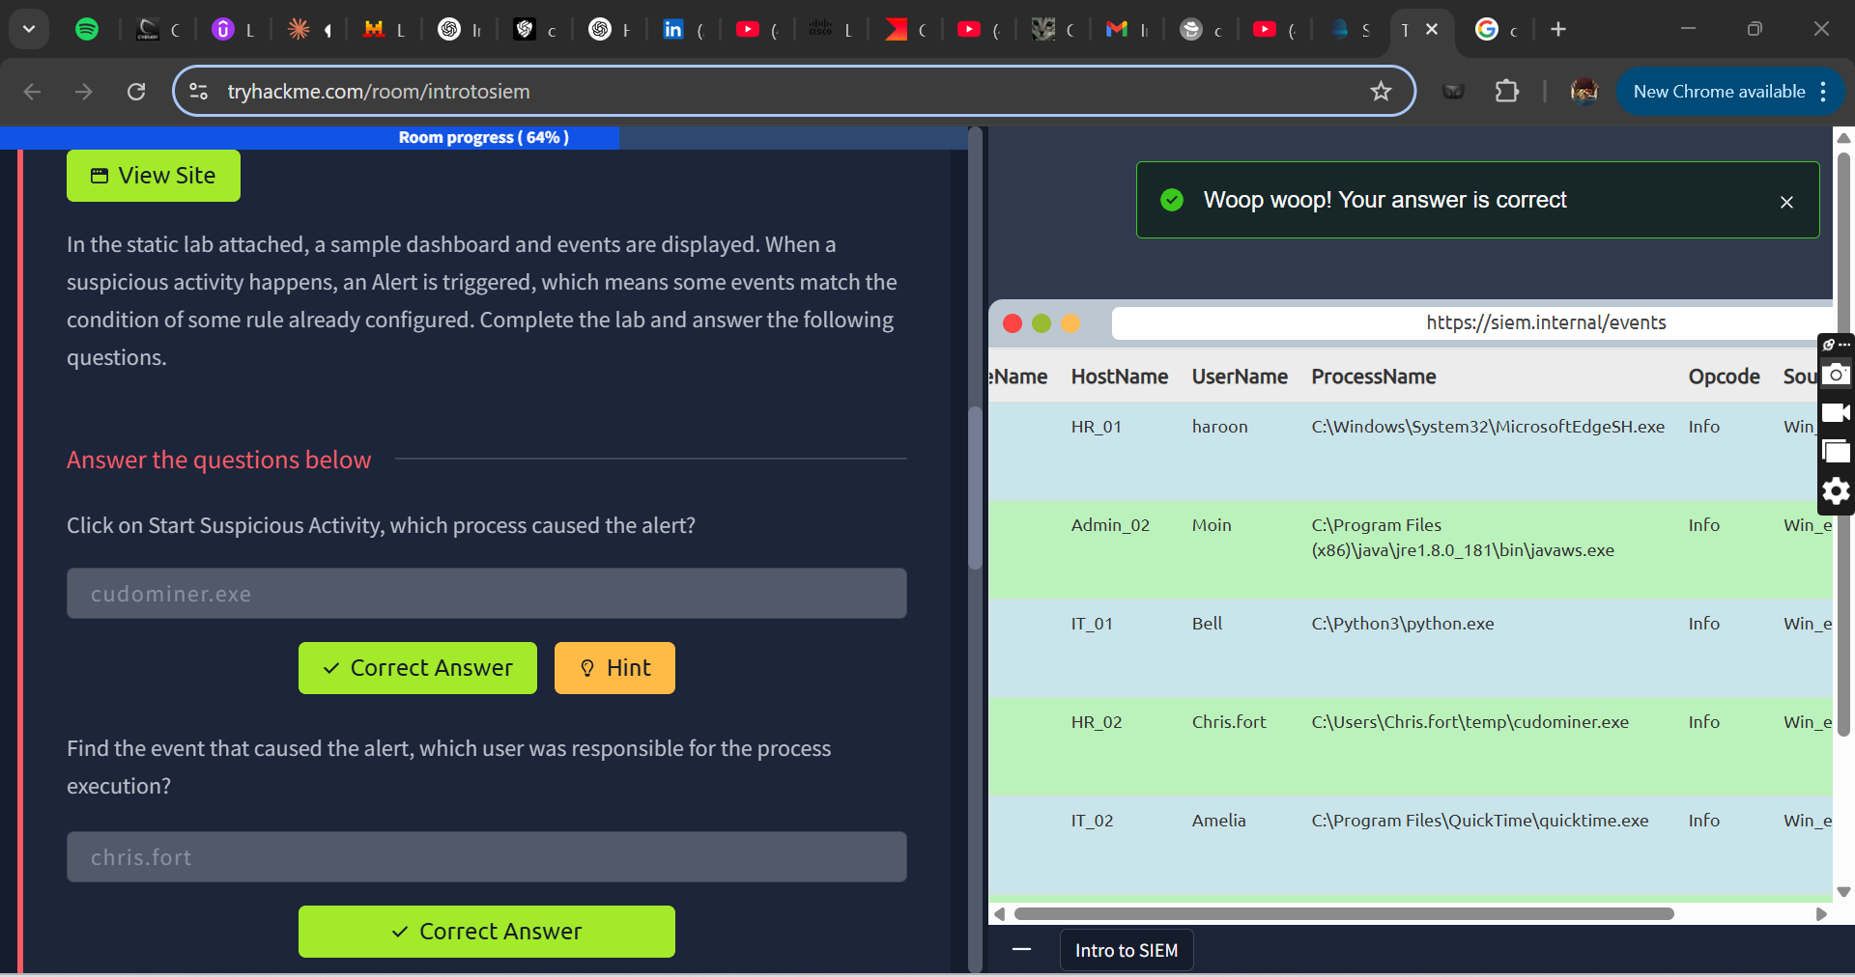

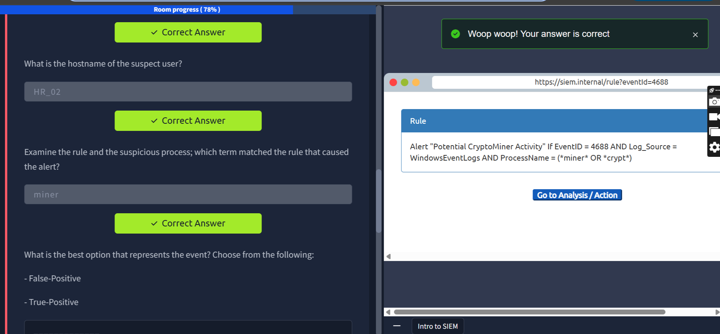

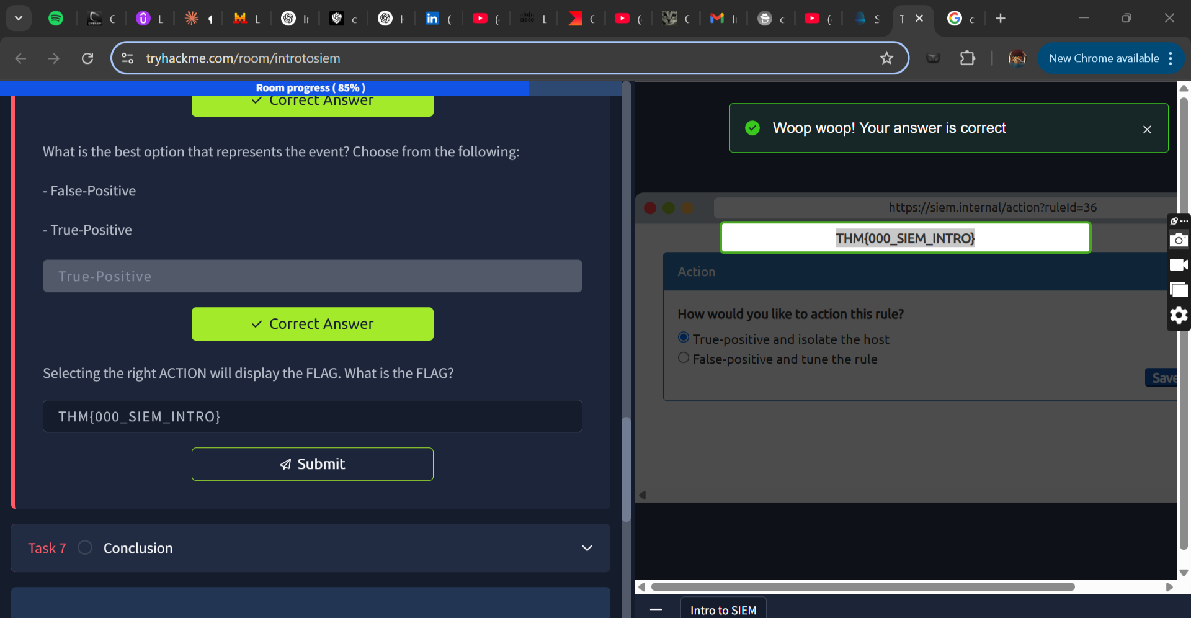

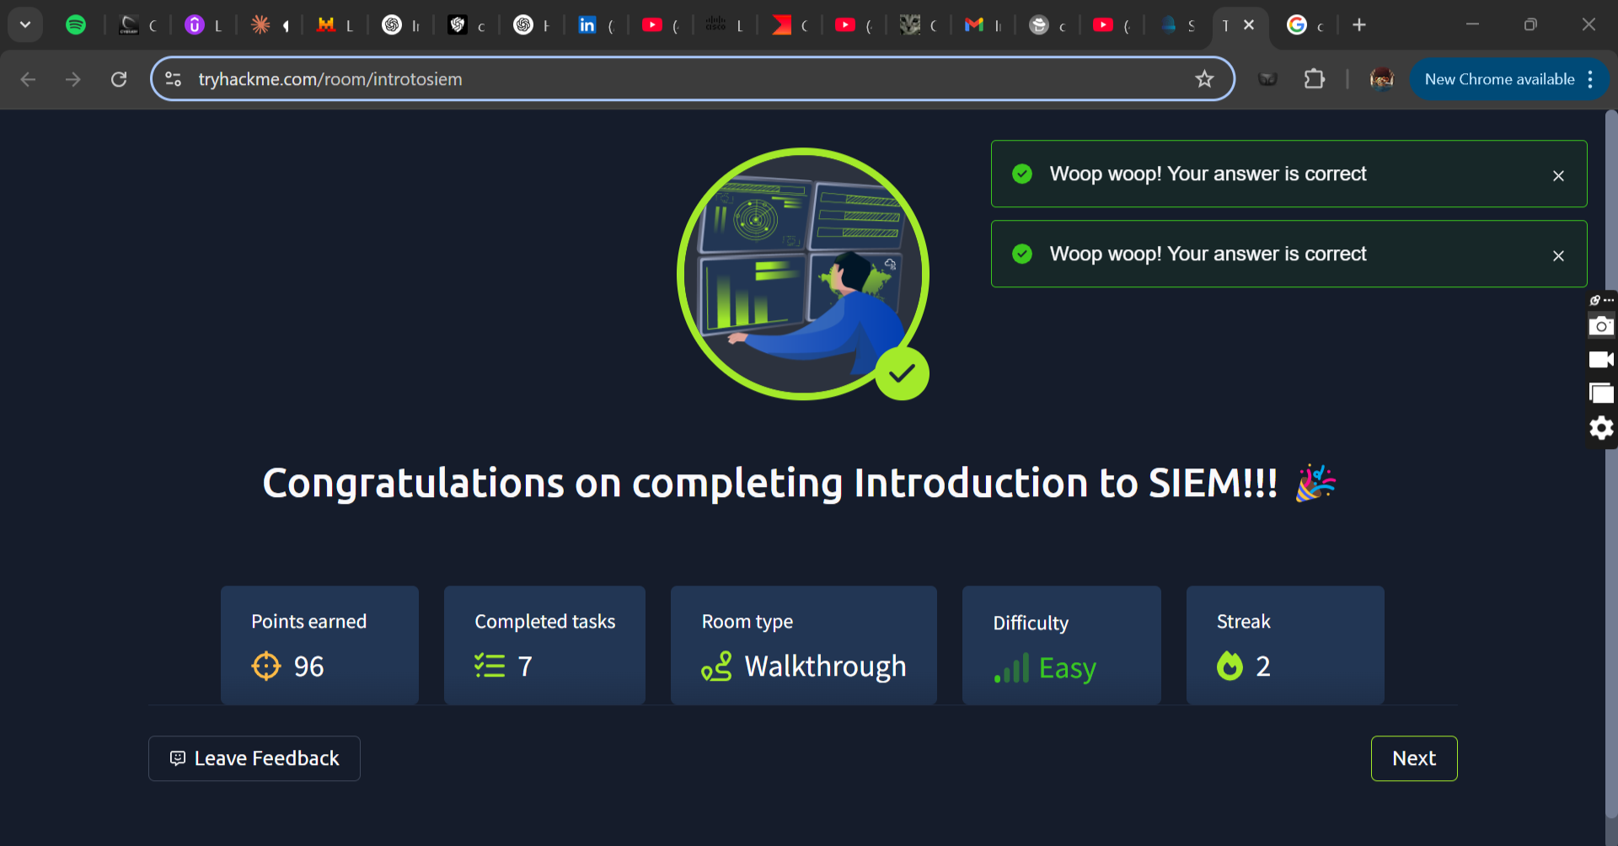

**Room: Splunk Exploring SPL**

1. **Search & Reporting App Overview**

**QSTN:** **In the search History, what is the 7th search query in the list**

**ANSW:** **index=windowslogs | chart count(EventCode) by Image**

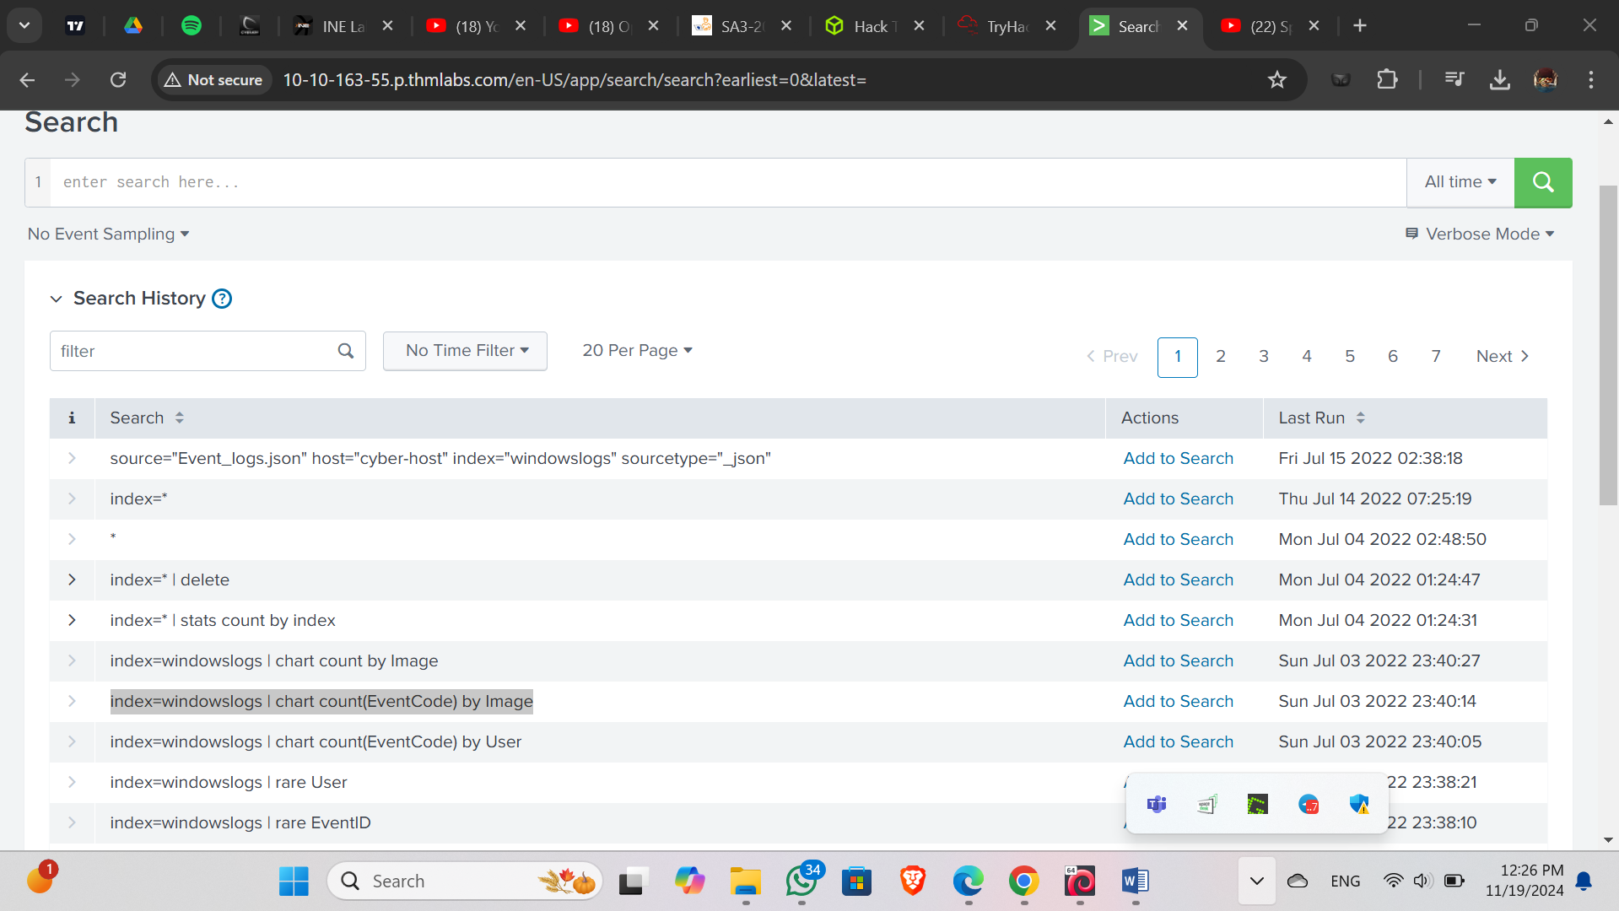

**QSTN:** **In the left field panel, which Source IP has recorded max events?**

**ANSW:** **172.90.12.11**

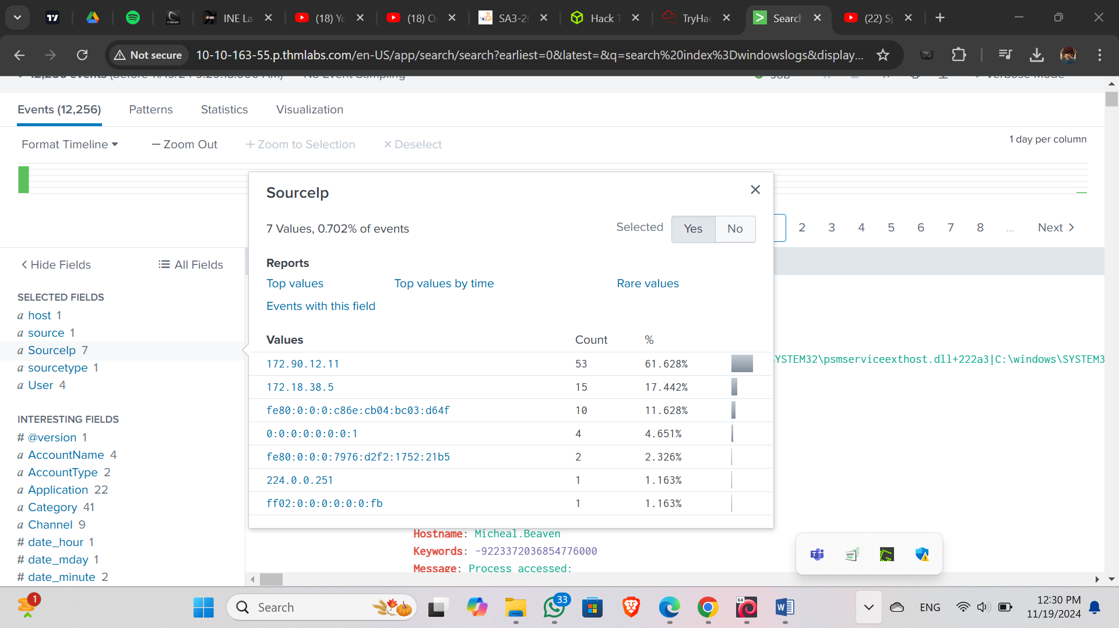

**QSTN:** **How many events are returned when we apply the time filter to display events on 04/15/2022 and Time from 08:05 AM to 08:06 AM?**

**ANSW:134**

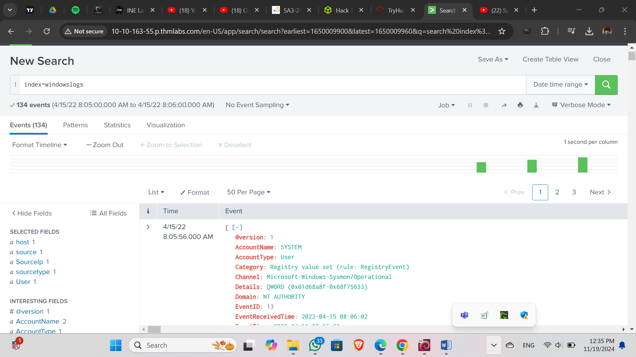

**QSTN:** **How many Events are returned when searching for Event ID 1 AND User as *James*?**

**ANSW: 4**

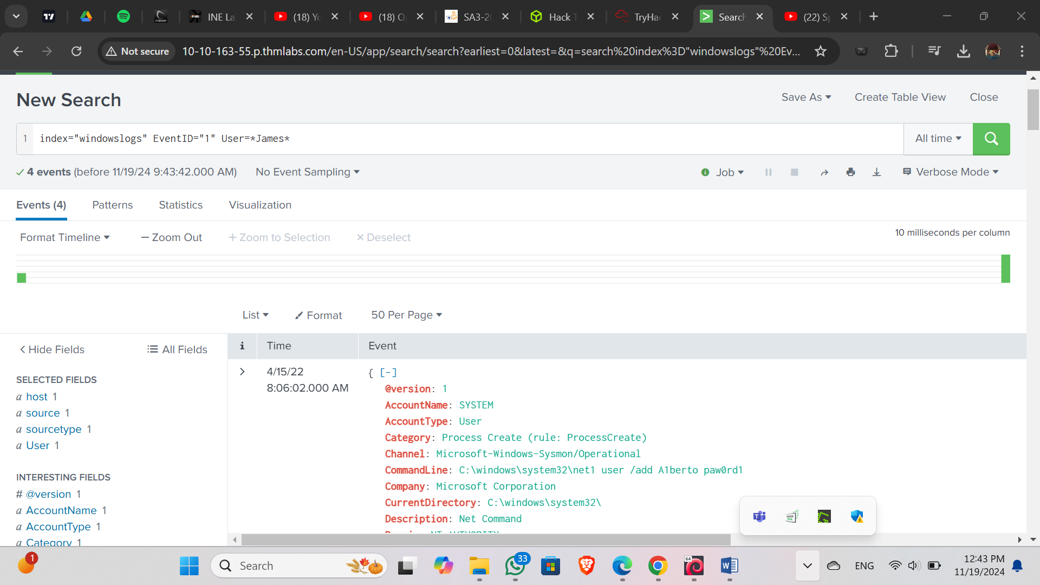

**QSTN:** **How many events are observed with Destination IP 172.18.39.6 AND destination Port 135?**

**ANSW:4**

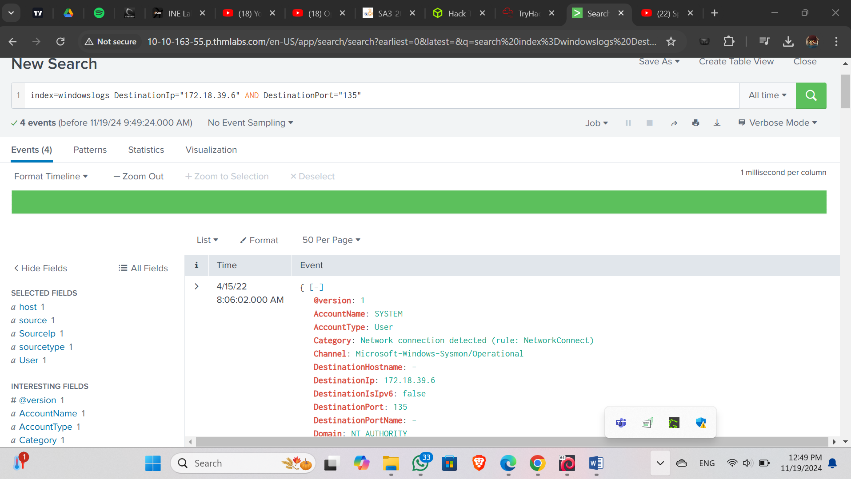

**QSTN:** **What is the Source IP with highest count returned with this Search query?**

**Search Query: index=windowslogs Hostname="Salena.Adam" DestinationIp="172.18.38.5**

**ANSW:** **172.90.12.11**

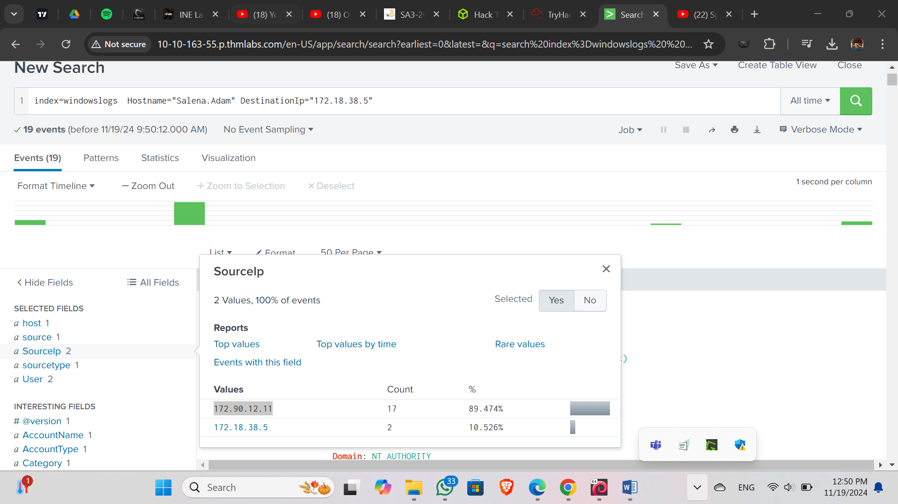**QSTN:** **In the index windowslogs, search for all the events that contain the term cyber how many events returned?**

**ANSW:0**

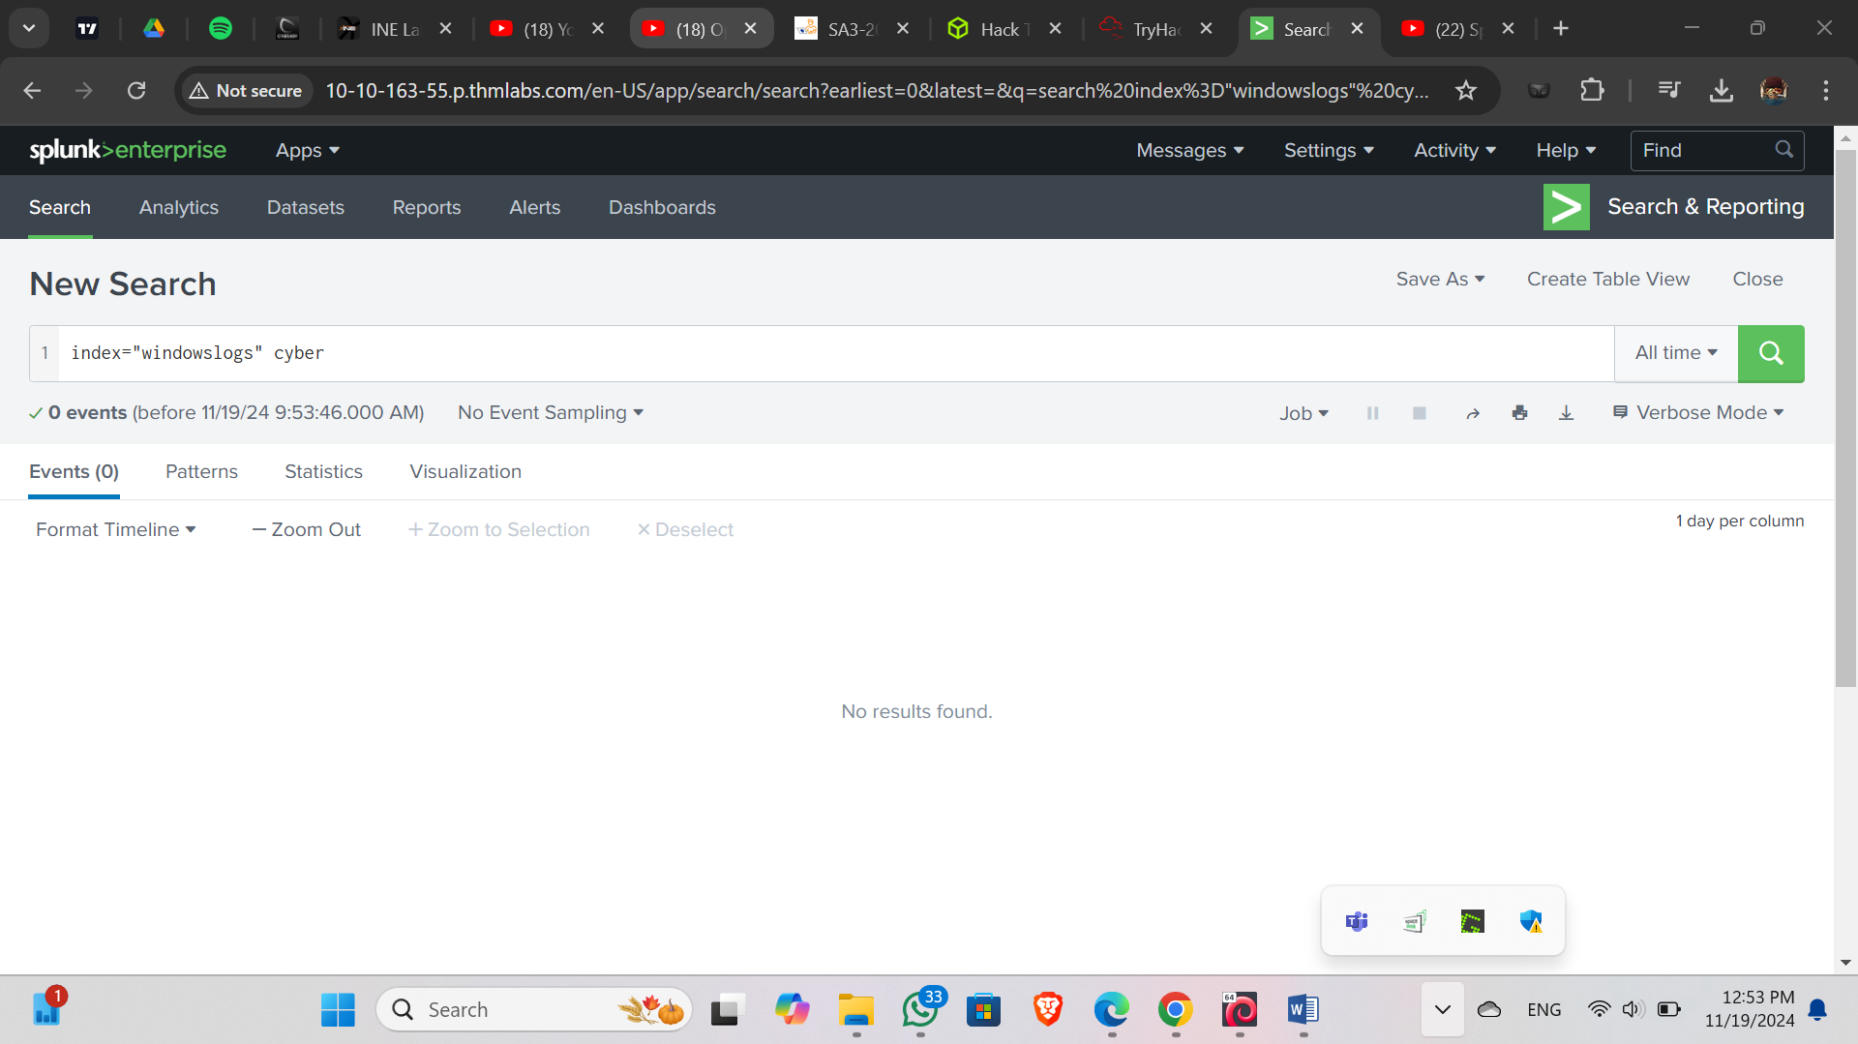

**QSTN:** **Now search for the term cyber*, how many events are returned?**

**ANSW:12256**

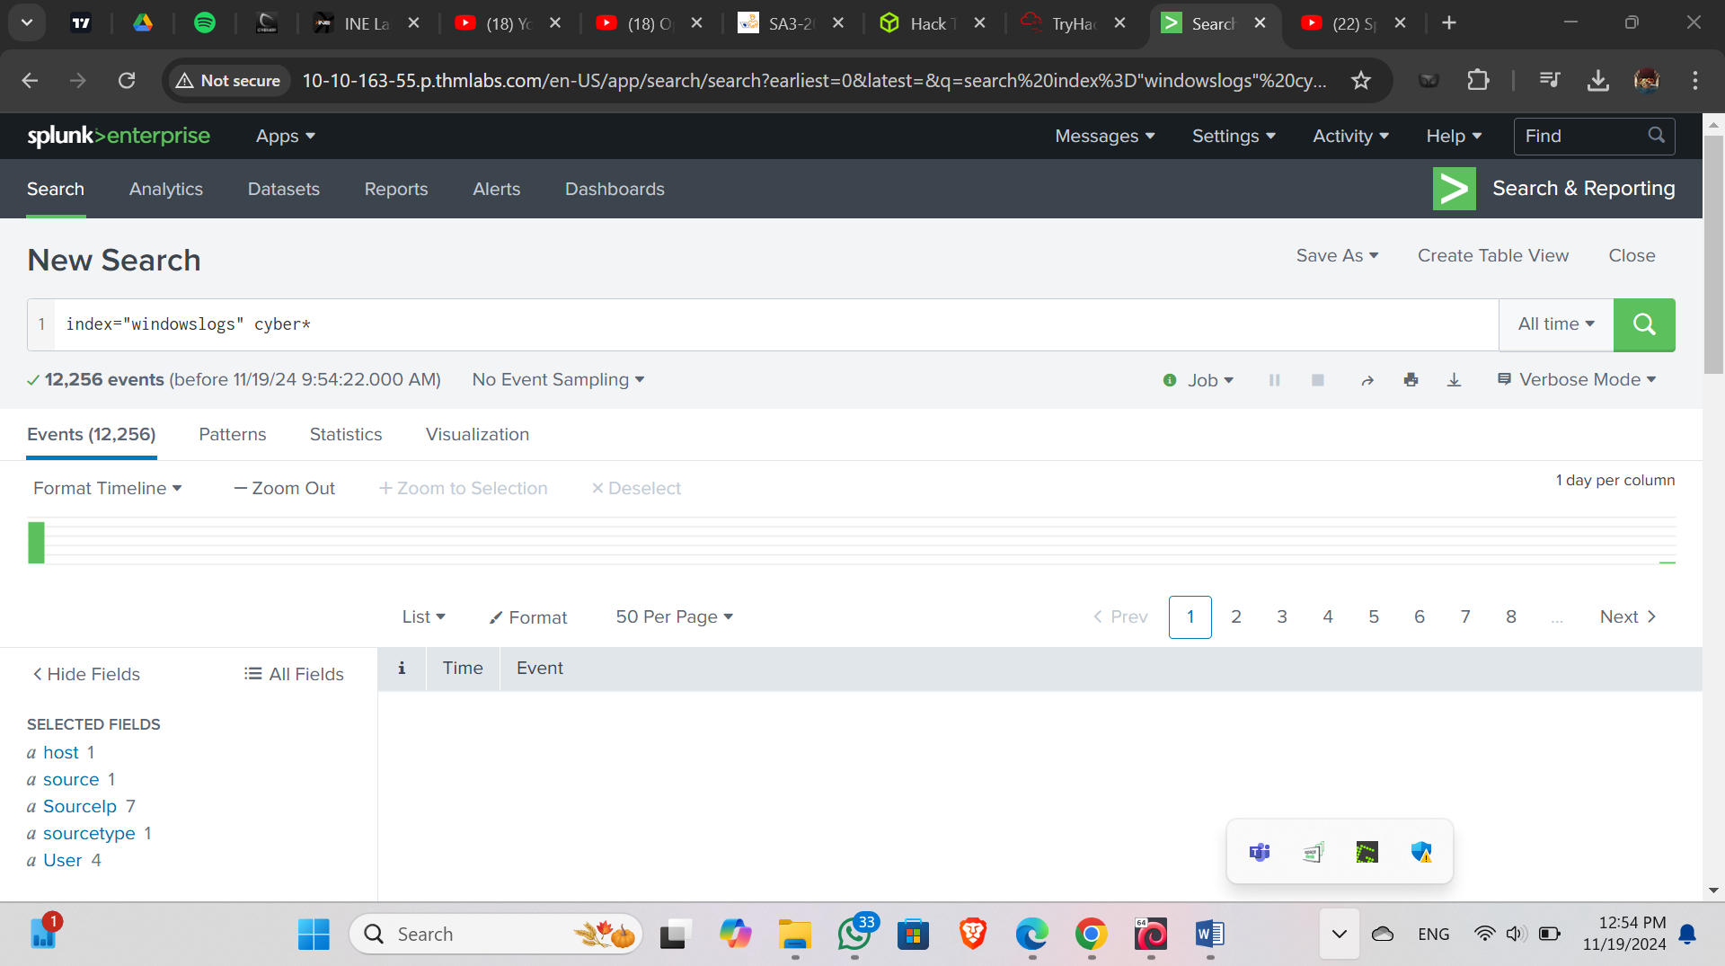

1. **Filtering the results in SPL**

**QSTN:** **What is the third EventID returned against this search query?**

**Search Query: index=windowslogs | table _time EventID Hostname SourceName | reverse**

**ANSW:4103**

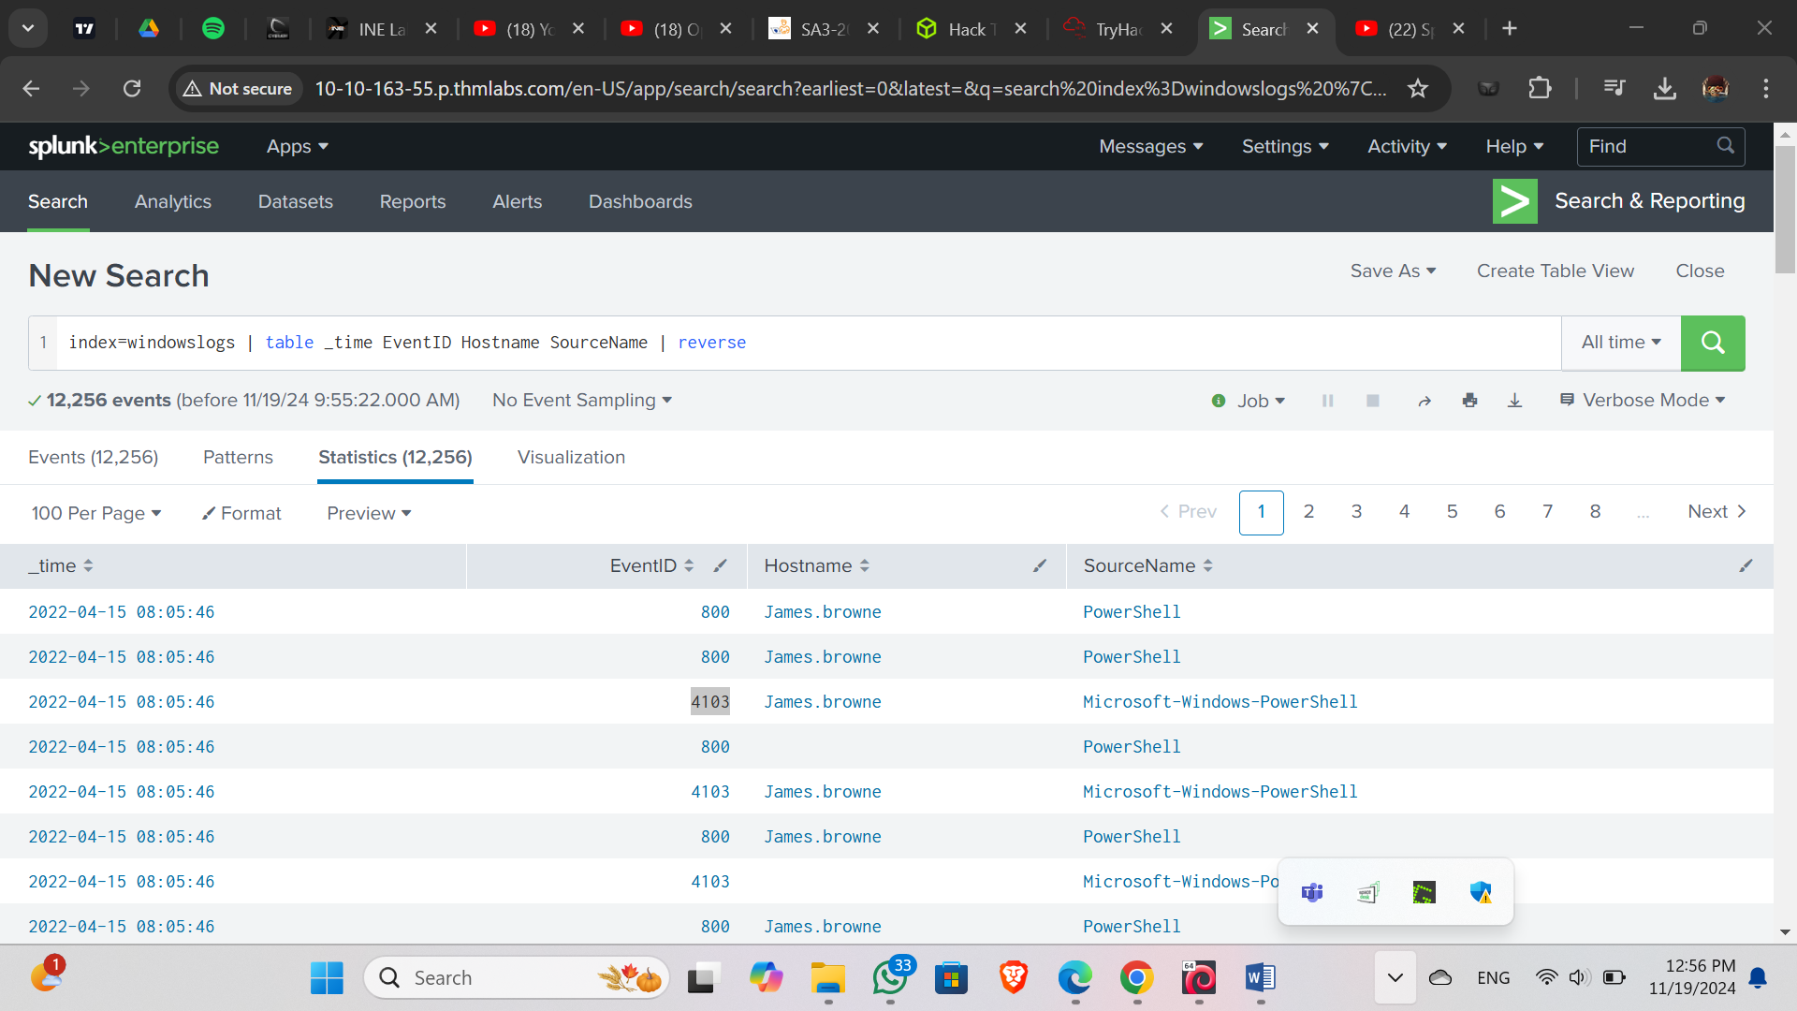

**QSTN:** **Use the dedup command against the Hostname field before the reverse command in the query mentioned in Question 1. What is the first username returned in the Hostname field?**

**ANSW:** **Salena.Adam**

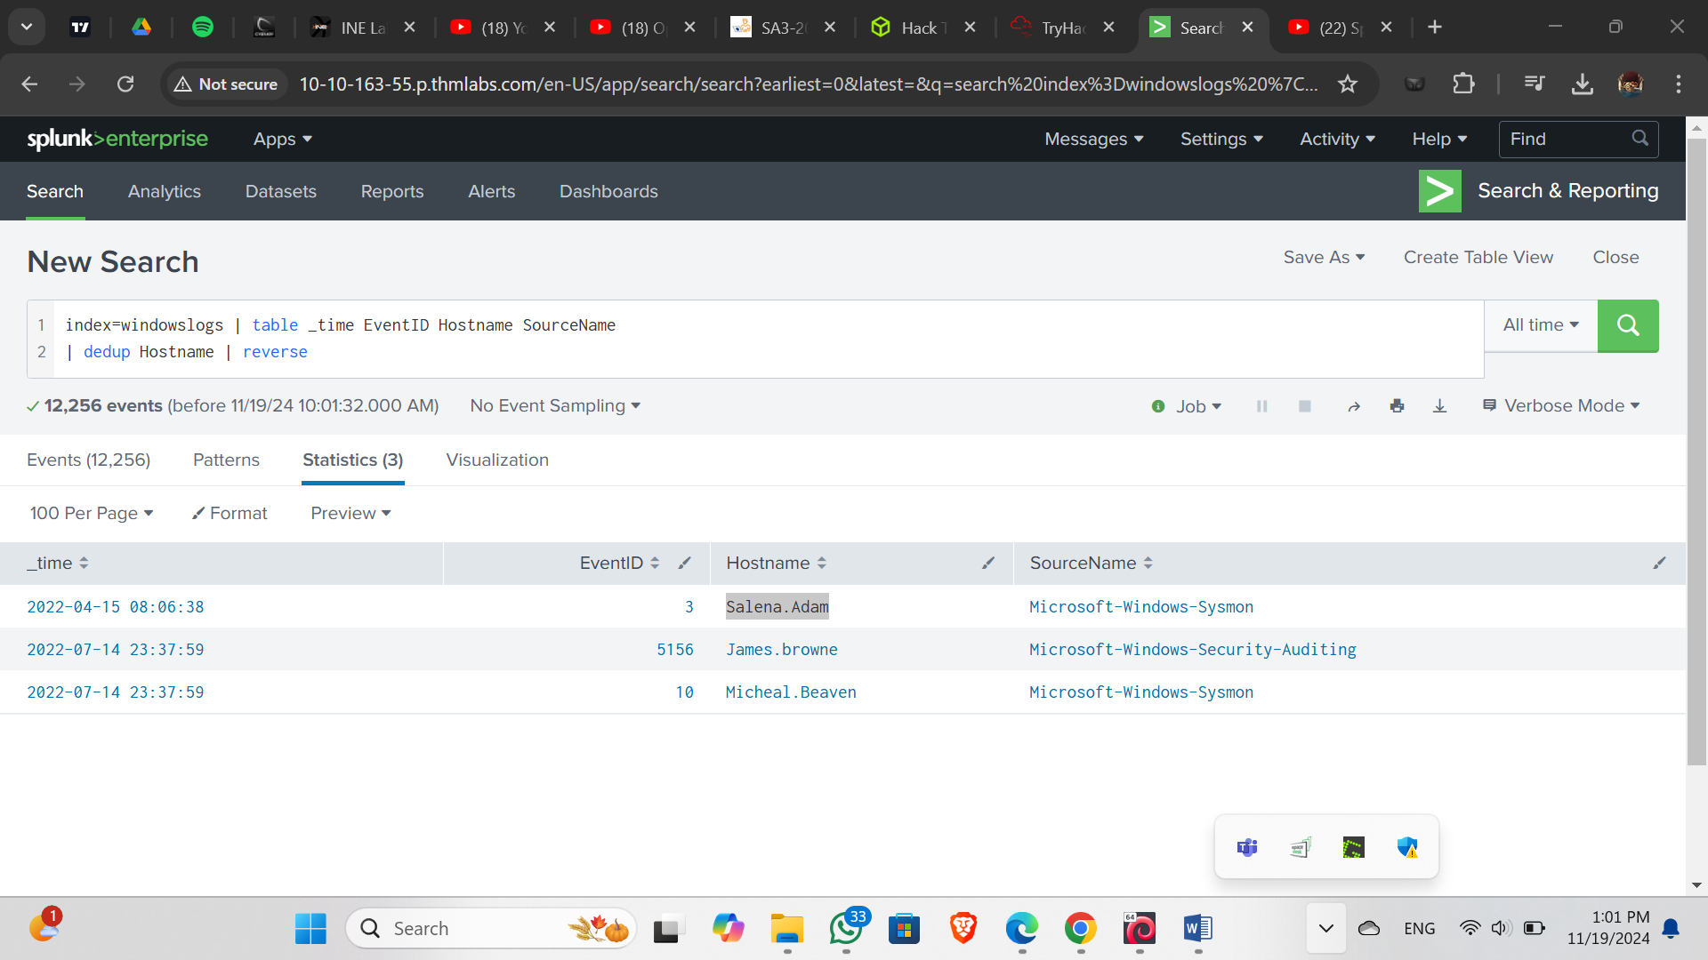

**QSTN:** **Using the Reverse command with the search query index=windowslogs | table _time EventID Hostname SourceName - what is the HostName that comes on top?**

**ANSW:James.browne**

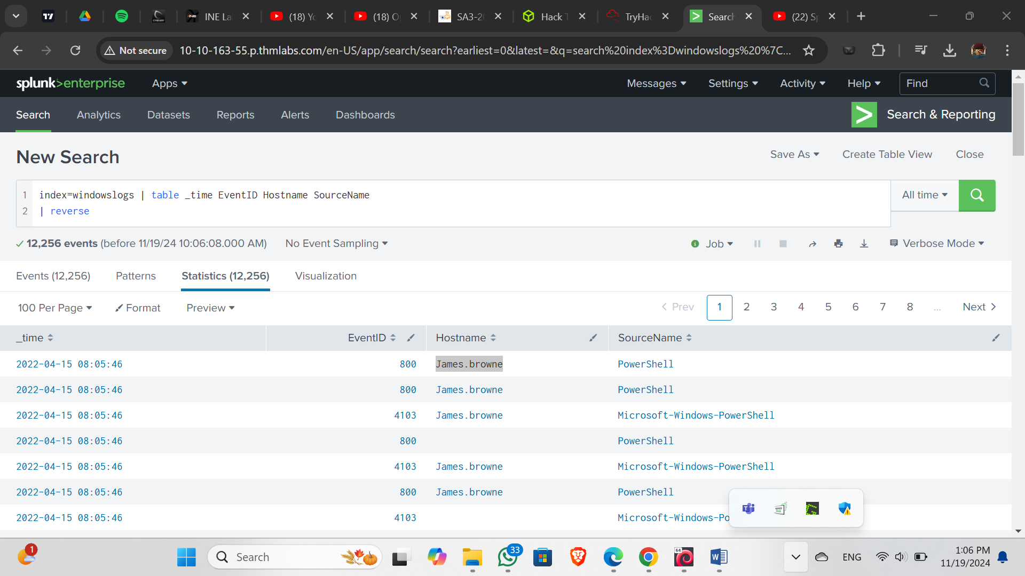

**QSTN:** **What is the last EventID returned when the query in question 1 is updated with the tail command?**

**ANSW:4103**

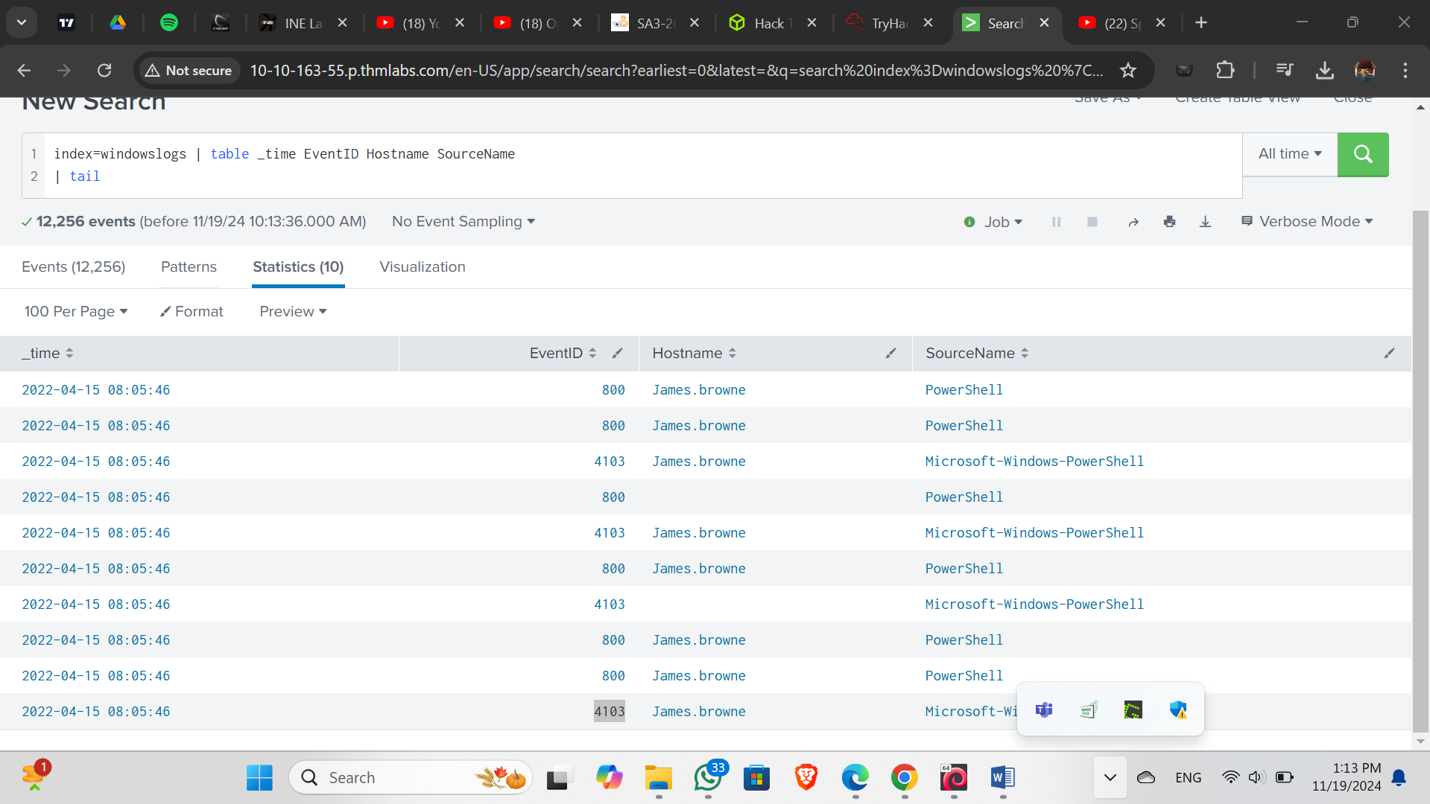

**QSTN:** **Sort the above query against the SourceName. What is the top SourceName returned?**

**ANSW:** **Microsoft-Windows-Directory-Services-SAM**

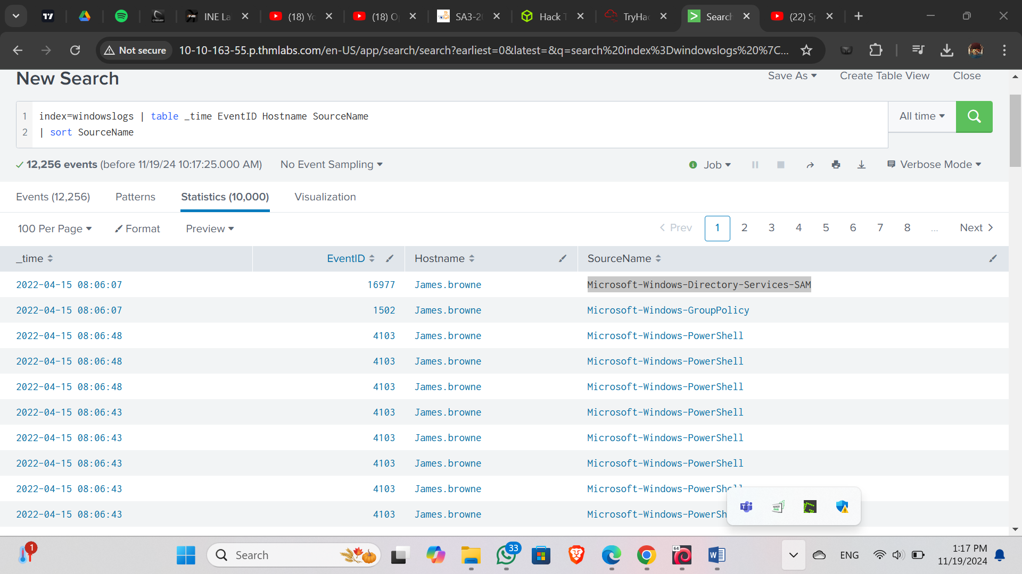

**QSTN:** **List the top 8 Image processes using the top command -  what is the total count of the 6th Image?**

**ANSW:196**

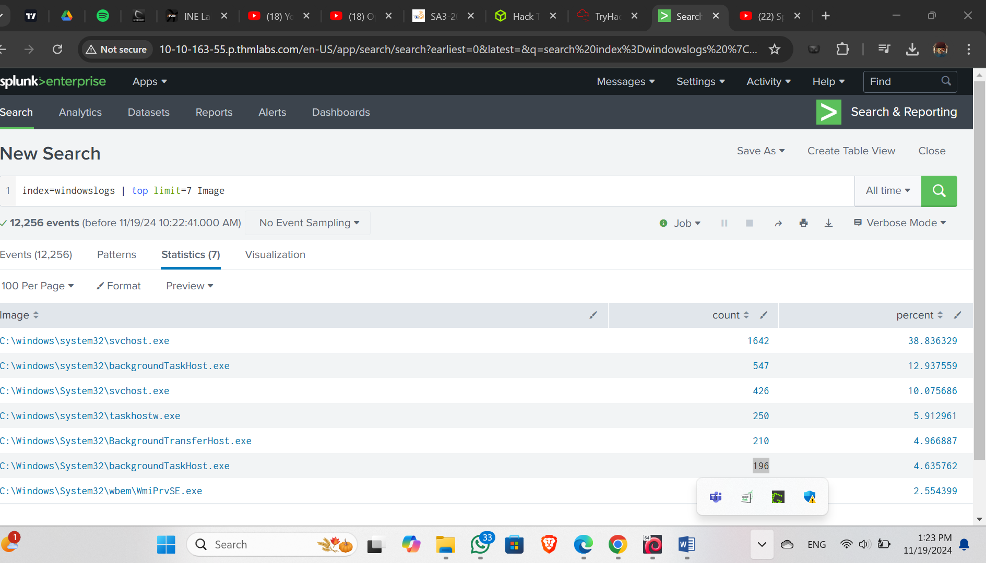

**QSTN:** **Using the rare command, identify the user with the least number of activities captured?**

**ANSW: James**

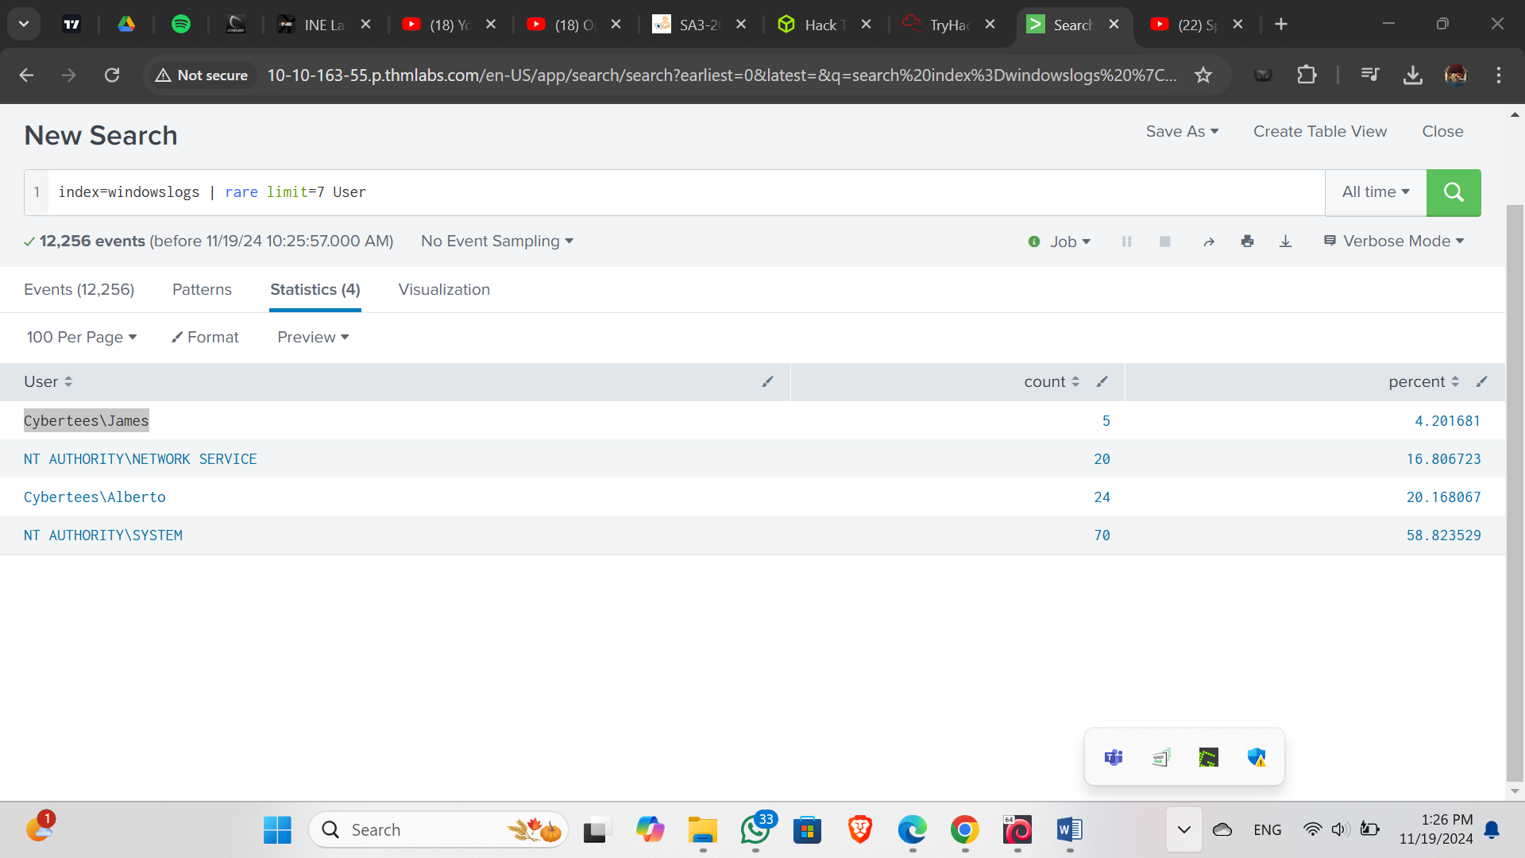

**QSTN:** **Create a pie-chart using the chart command - what is the count for the conhost.exe process?**

**ANSW:70**

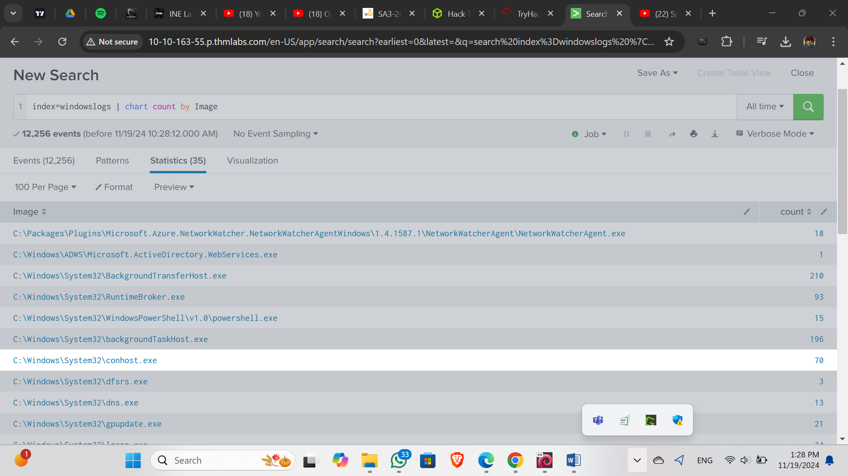

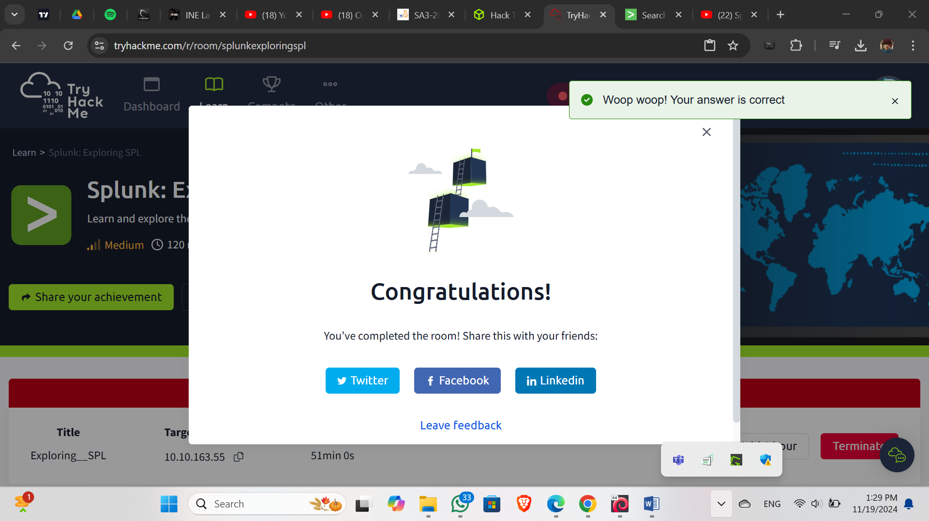

**4.0 Reflection**

Using a SIEM tool provided valuable insights into how organizations detect and respond to cybersecurity threats in real time. Key learnings include:

* **The power of centralization:** Having a single pane of glass for log analysis drastically improves visibility and decision-making.
* **Correlating seemingly unrelated events:** Interns witnessed how failed logins, unusual traffic patterns, and endpoint alerts can collectively indicate a coordinated attack.
* **The importance of context:** Raw logs can be overwhelming. SIEM tools normalize and contextualize data, making it actionable.
* **Hands-on skill development:** Creating custom alerts and dashboards improved understanding of how attackers move laterally or attempt persistence.

This practical experience is essential for any cybersecurity professional aspiring to work in a SOC or threat detection role.

**5.0 Appendix**

**A. Key SIEM Terms**

| Term | Definition |
| --- | --- |
| SIEM | Security Information and Event Management |
| IOC | Indicator of Compromise |
| Correlation Rule | Logic used to link events and detect patterns of malicious behavior |
| Dashboard | Visual summary of security metrics and alerts |
| False Positive | An alert that appears malicious but is benign |

**B. Common SIEM Tools**

| Tool | Use Case |
| --- | --- |
| Splunk | Enterprise-scale log management |
| QRadar | IBM’s SIEM with strong AI features |
| Elastic SIEM | Open-source, lightweight SIEM |
| ArcSight | Strong in compliance/reporting |
| Microsoft Sentinel | Cloud-native SIEM with tight Azure integration |

C. Sample Alert Workflow

1. Event Triggered: Excessive failed login attempts
2. SIEM Alert Generated
3. Analyst Triage: Confirmed abnormal behavior
4. Escalation to Tier 2
5. Containment: Lock account and investigate source IP
6. Resolution: Block malicious actor, issue report

This Internship Task report was developed on april 14, 2025

By:

Manasseh Mutugi

[manassehmutugi222@gmail.com](mailto:manassehmutugi222@gmail.com)